Final Project: Part 1 - GitHub UI
GitHub Repo Link:
https://github.com/ADVAIT135/github-final-project.git
GitHub Readme URL:
https://github.com/ADVAIT135/github-final-project/blob/3a4b29ecc0b1727c304ed33e94492e54c32eb10a/README.md
Apache License 2.0:
https://github.com/ADVAIT135/github-final-project/blob/3a4b29ecc0b1727c304ed33e94492e54c32eb10a/LICENSE
Code of conduct
https://github.com/ADVAIT135/github-final-project/blob/24e9eb6b4432105674d8c85dee9255fc81fbbf68/CODE_OF_CONDUCT.md
Contribution
https://github.com/ADVAIT135/github-final-project/blob/de4e7746bb5ff57e259d851daccc4de1c5e1acc9/CONTRIBUTING.md
Simple Interest Calculator
https://github.com/ADVAIT135/github-final-project/blob/09b0d6ff344a9ad6333641a503d98f0a38ec7638/simple-interest.sh

Final Project: Part 2 - Git CLI
Task 1: Fork the repository
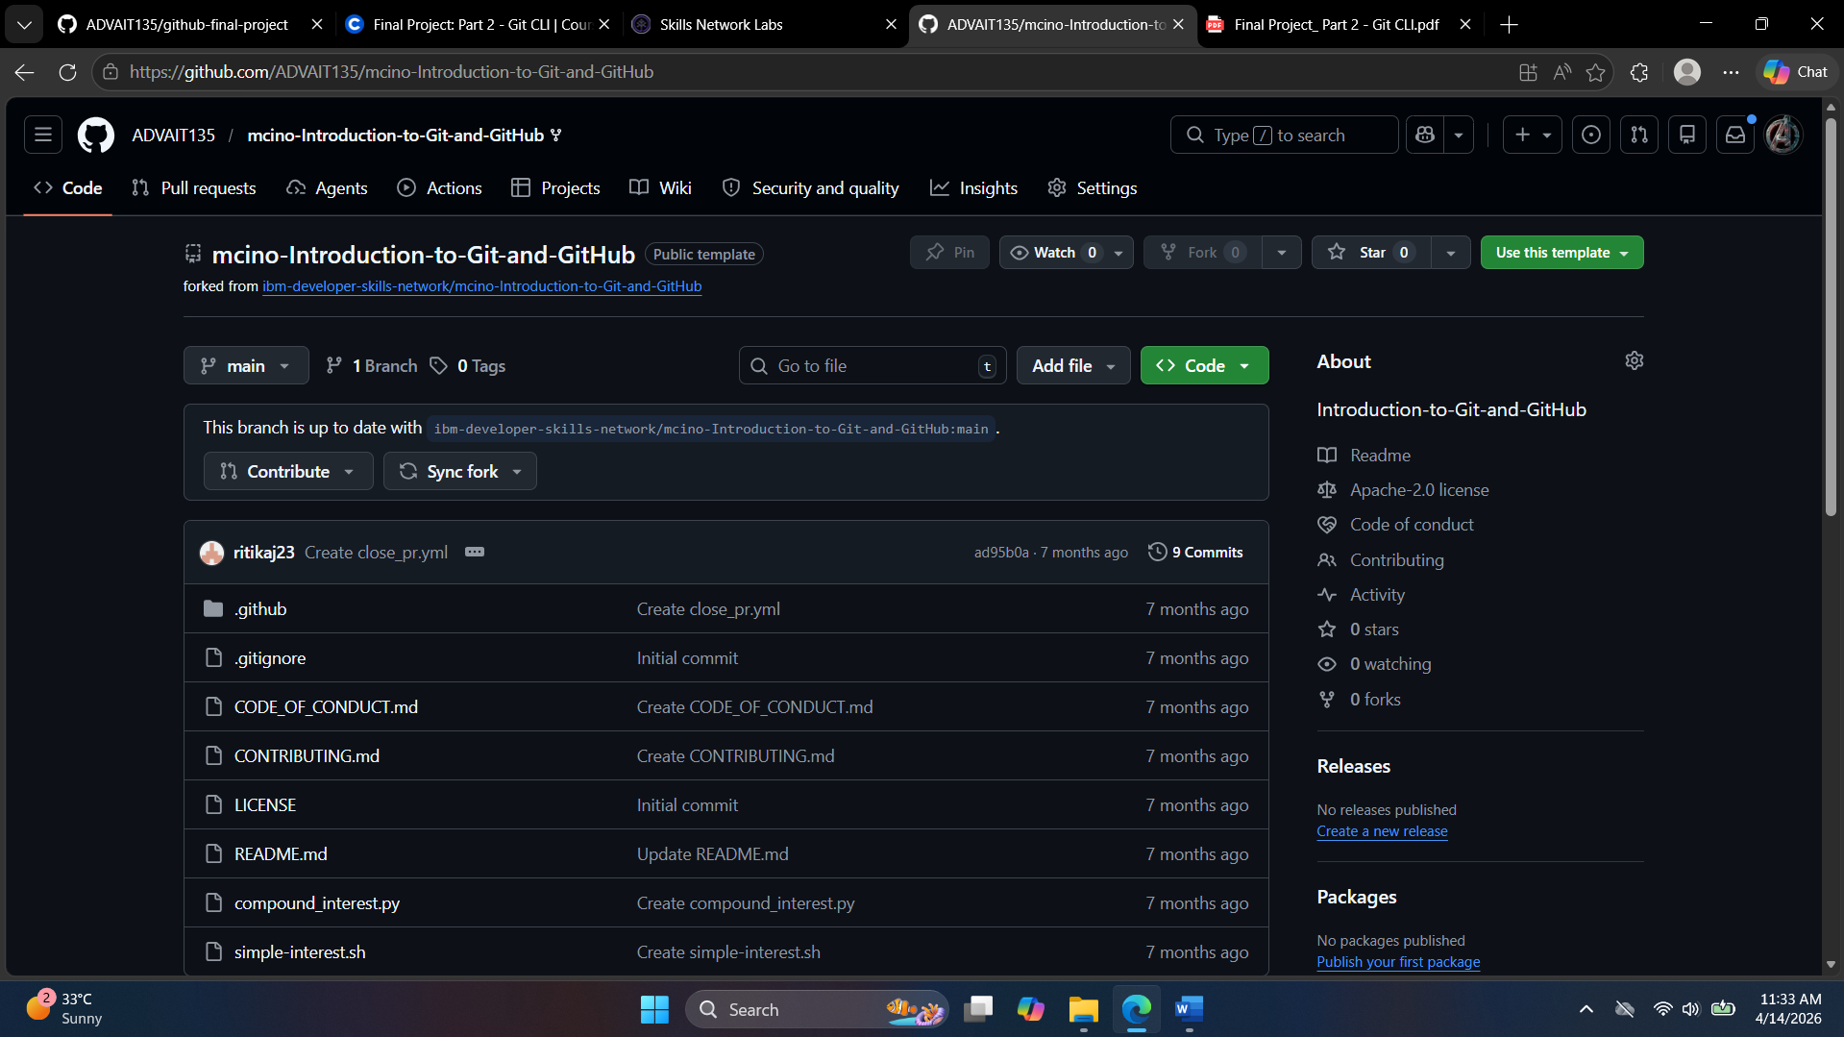

curl -s https://api.github.com/repos/ADVAIT135/mcino-Introduction-to-Git-and-GitHub | jq -r '.parent.clone_url'
https://github.com/ADVAIT135/mcino-Introduction-to-Git-and-GitHub.git

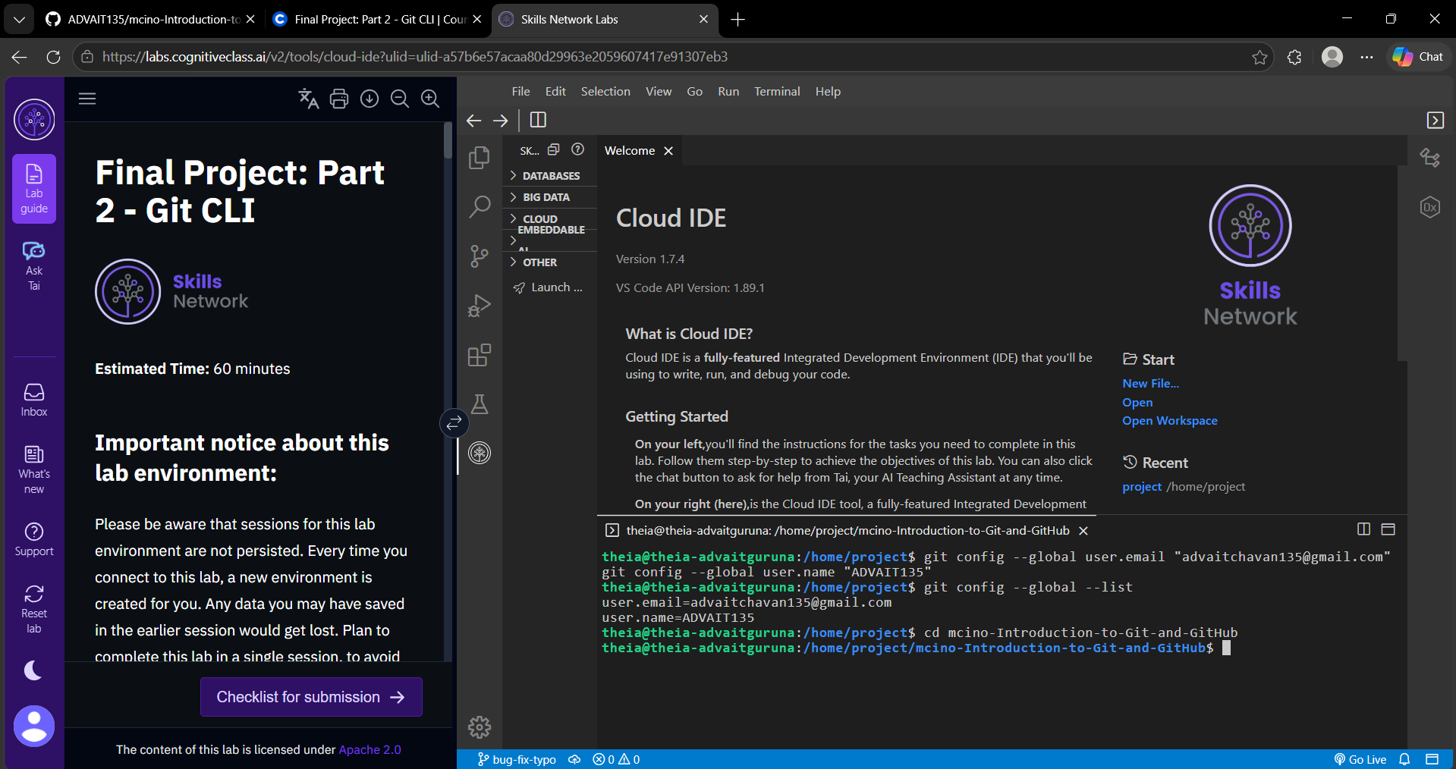

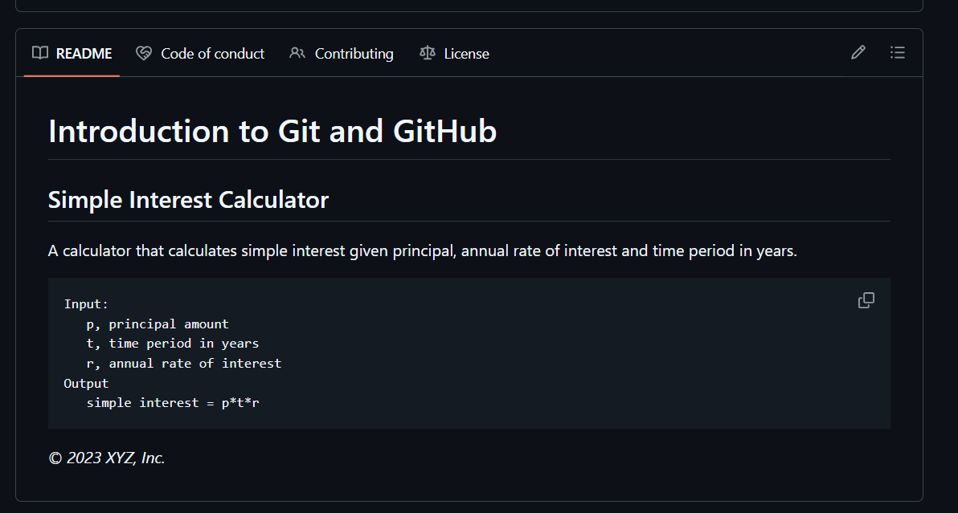

git config --global user.email “advaitchavan135@gmail.com”
git config --global user.name "ADVAIT135”

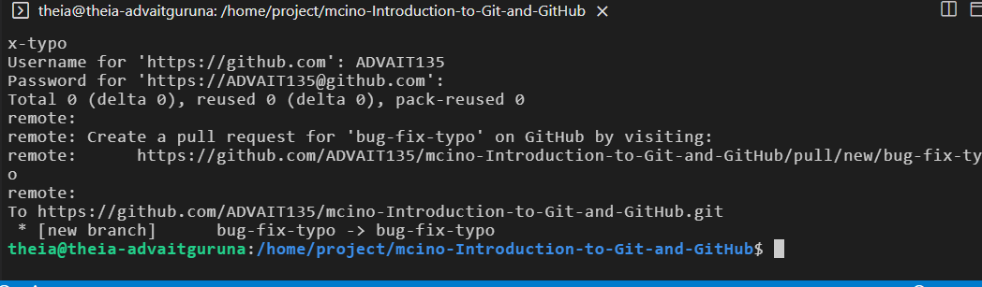
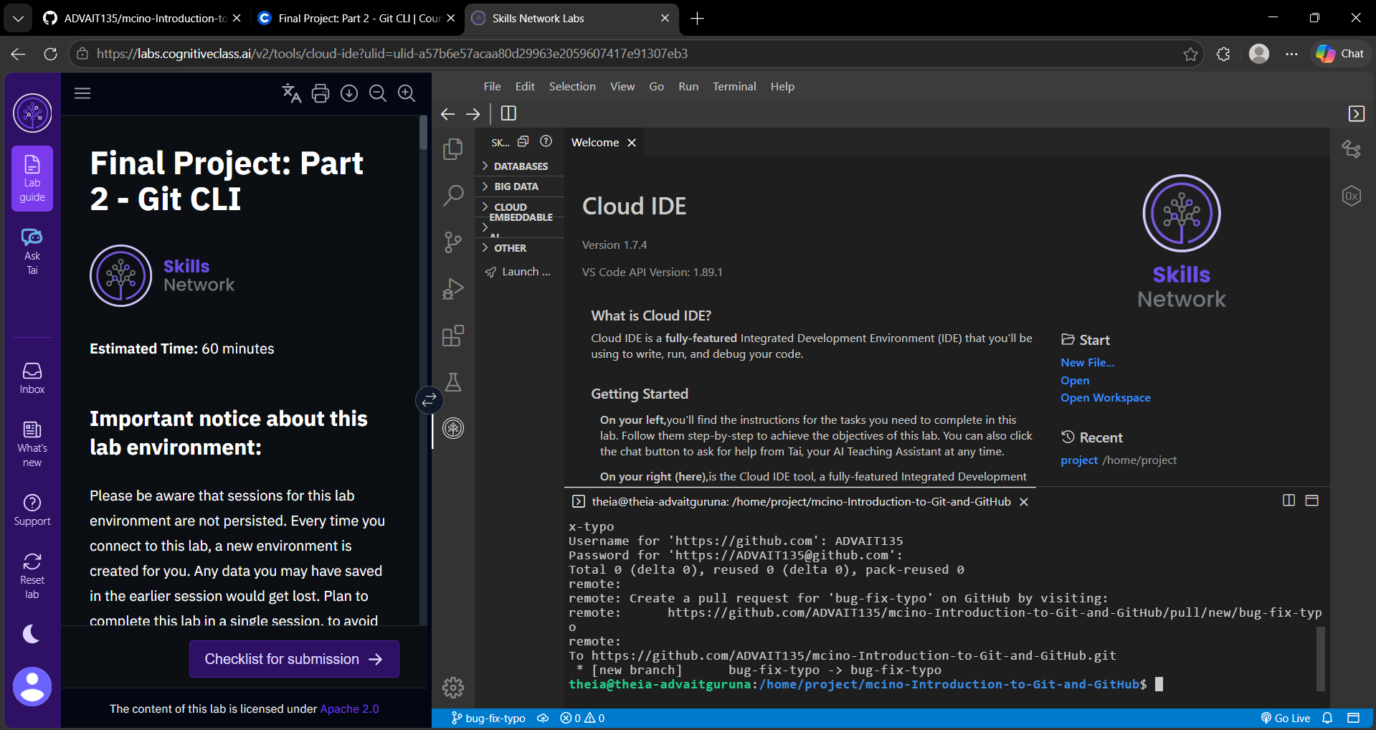
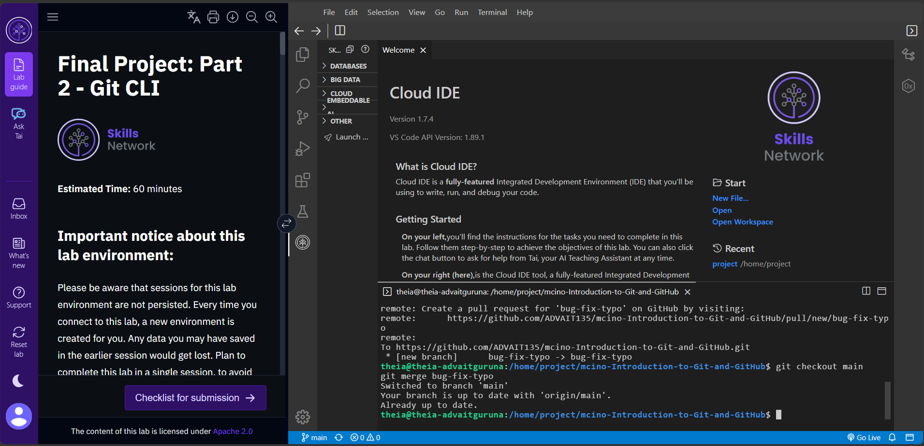
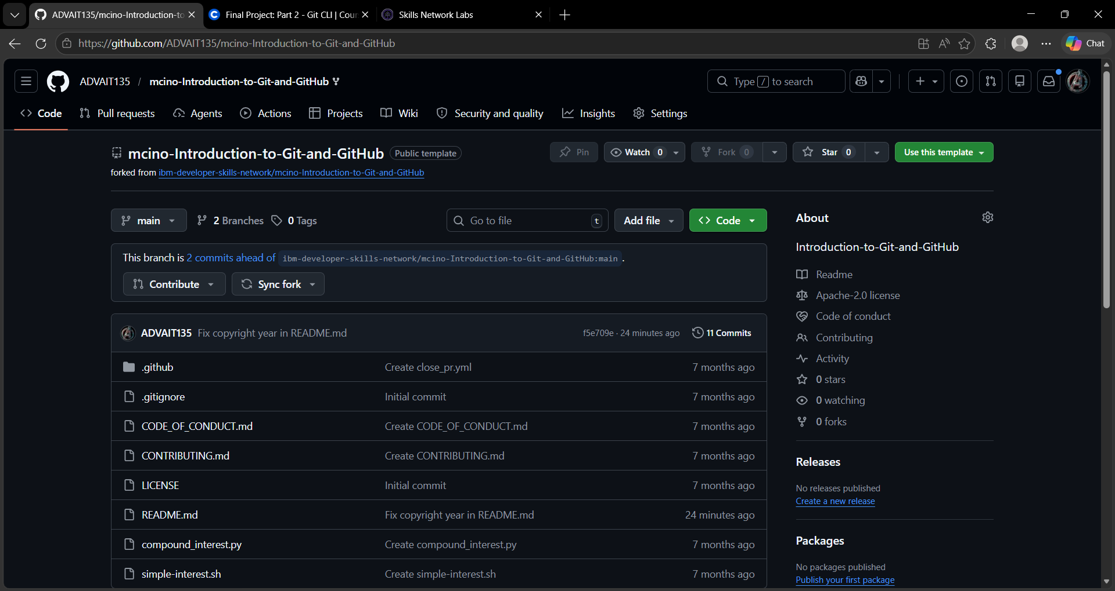
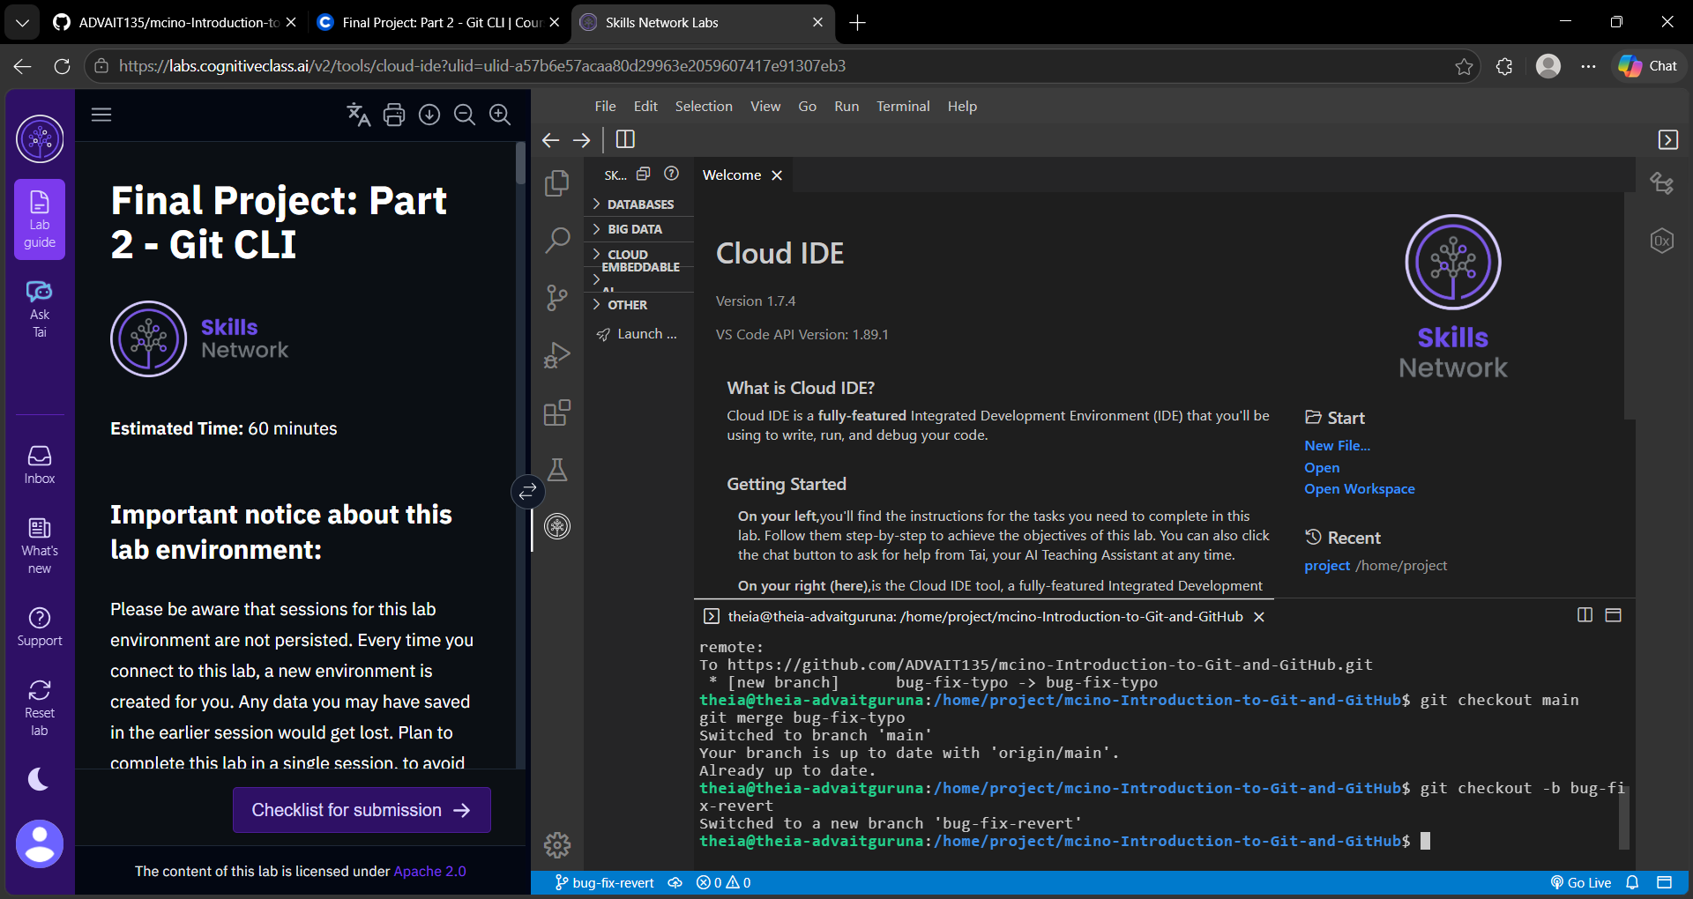

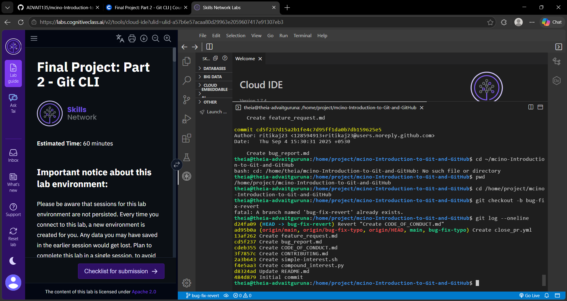
git revert d8324ad

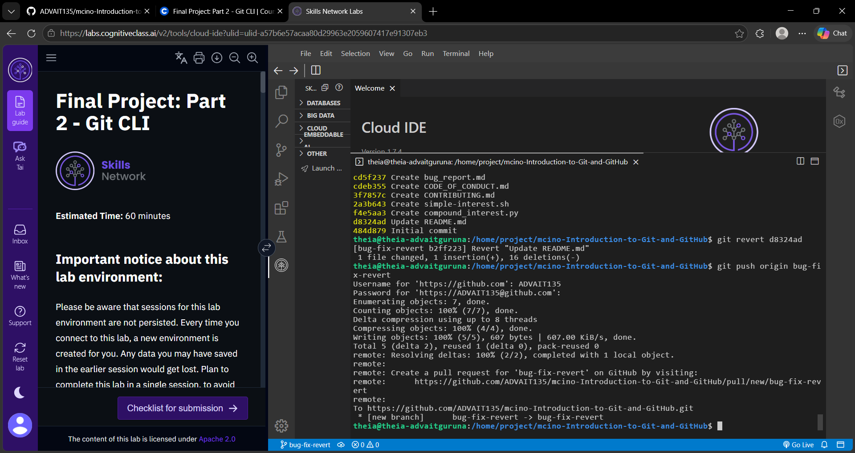

curl -s https://api.github.com/repos/ibm-developer-skills-network/mcino-Introduction-to-Git-and-GitHub/pulls/6855

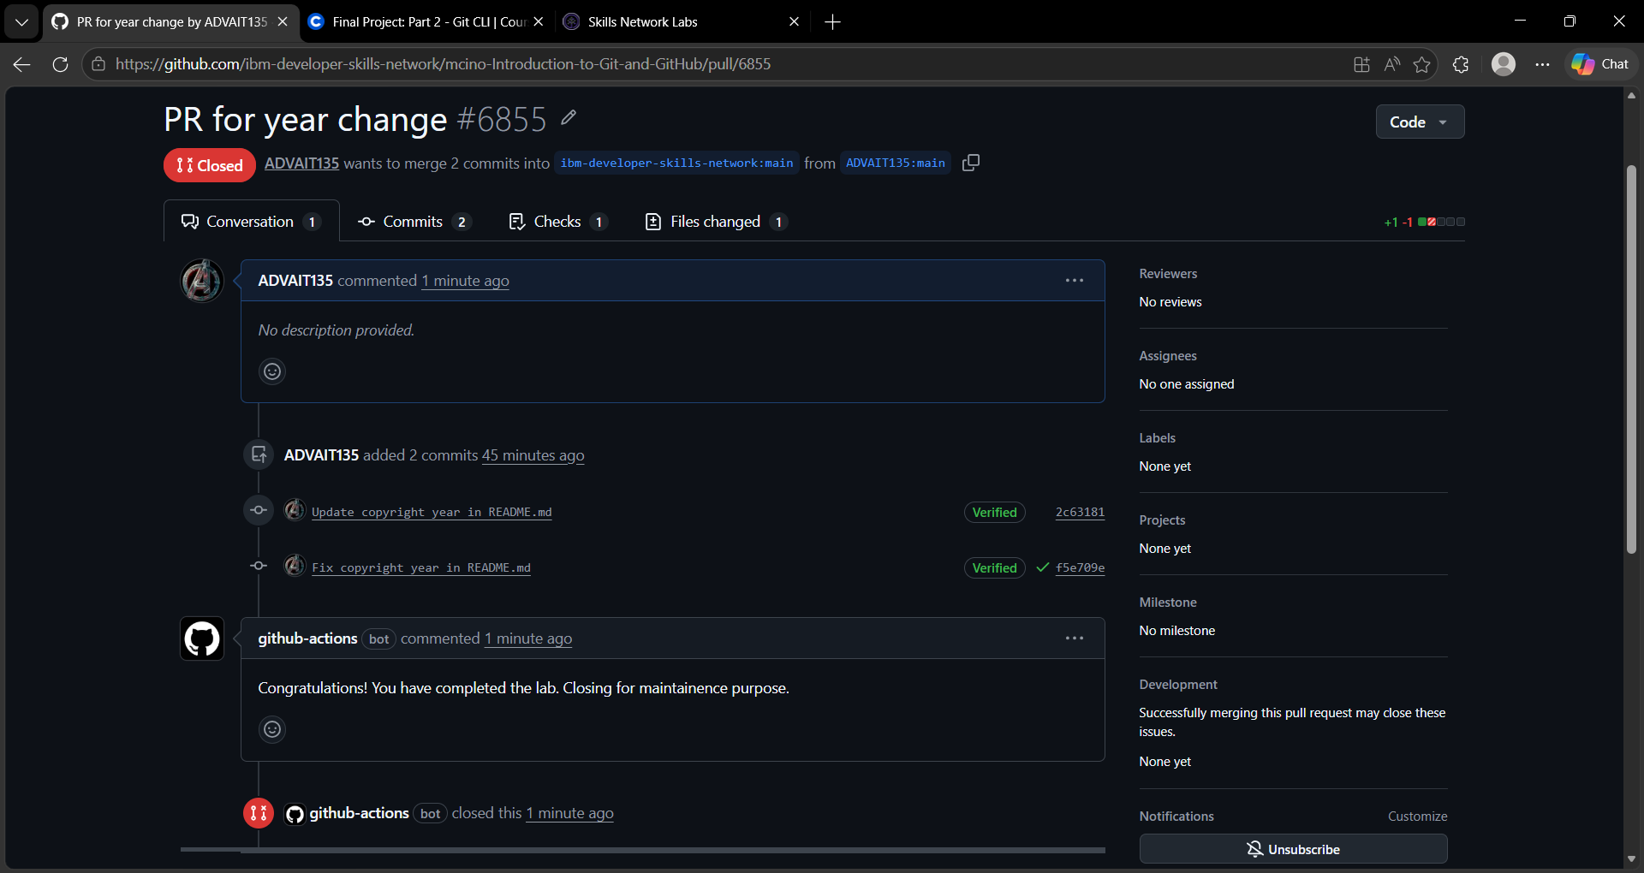
https://github.com/ADVAIT135/mcino-Introduction-to-Git-and-GitHub/branches
